**Kamala College,Kolhapur**



**A**

**PROJECT REPORT**

**ON**

**“ICECREAM SHOP”**

**SUBMITTED TO,**

**SHIVAJI UNIVERSITY KOLHAPUR**

**IN THE PARTIAL FULFILLMENT OF DEGREE IN**

**BACHELOR OF COMPUTER APPLICATION**

**BCA-II (Semester-IV)**

**SUBMITTED BY**

**Miss. Vaishnavi Anandrao Ghorpade.**

**Miss.Gayatri Dashrath Palhade .**

**UNDER THE GUIDANCE OF**

**Smt. Rohini Lokare**

**(2023-24)**

**Kamala College,Kolhapur**



**Certificate**

This is to certified that, Miss. **Vaishnavi Anandrao Ghorpade**, Miss.**Gayatri Dashrath Palhade.**has satisfactorily completed the project work on the title “Ice-Cream Shop”developed in “HTML Language”. For the practical fulfillment of BCA-II (Semester-IV) submitted to Shivaji University Kolhapur. During the academic year 2023-24 under my guidance .To the best of our knowledge and belief the matter presented by them is original work at not copied from any source.

Place: Kamala College, Kolhapur

Date:

Miss.Rohini Lokare Mss.Rohini Lokare

(Project Guide) External Examiner (H.O.D)

**Kamala College, Kolhapur**



**Declaration**

I here with declare that the project entitle is **“Ice-Cream Shop”** Completed and Written by me under guidance of Miss. **Rohini Lokare**. I further submit that the project work has been done by me and it has formed the basis for the partial fulfillment of Bachelor of Computer Application degree of Shivaji University Kolhapur. The empirical finding in these reports is based on work carried out by me during the course of the project work.

Place: Kamala College Kolhapur

Date:

Miss. Vaishnavi Anandrao Ghorpade.

Miss. Gayatri Dashrath Palhade.

**Kamala College, Kolhapur**



**Acknowledgement**

We have to great pleasure in submission of the project report on **“ICE-CREAM SHOP”** in partial fulfillment of BCA-II (Semester-IV).

While submitting this mini project report, we take this opportunity to thank those directly or indirectly related to project work without their active co-operation and guidance it would have become extremely difficult to complete this task in time.

At the outset, we keep on giving deep gratitude towards our project guide, Miss. Rohini Lokare. who gave guidance right from initial stage of projects and offered me several valuable suggestions for developing this project in systematic manner.

We also thankful to all other teacher form computer department and all staff of computer lab for their co-operation during the completion of this project.

**INDEX**

|  |  |  |
| --- | --- | --- |
| **SR NO.** | **PARTICULARS** | **PAGE NO.** |
| 01 | Introduction to Project | 6 |
| 02 | Proposed System | 7-12 |
| 03 | System Analysis | 13-19 |
| 04 | System Design | 20-26 |
| 05 | Implementation | 27-28 |
| 06 | Reports | 29-30 |
| 07 | Conclusion and Suggestions | 31 |
|  | Annexure | 32-44 |
|  | Student Guide Meet Record | 45 |
|  | Reference | 46 |

**Introduction to Project**

Welcome to our Ice-cream shoppy,where every scoop is taste of happiness! Ice-cream shop management based on concept to maintain are ice-cream ordering booking a table. By using this system He/She can maintain ordering record of a day. By selecting ice-cream order with item quantity. After that, He/She proceeds towards order confirmation and booking a table. Almost 90% of population are ice-cream lovers.

At ice-cream shoppy we from creamy classics like chocolate and vanilla to adventurous flavors like mango and blueberry, our menu offers something for every palate. Our commitment to quality ingredients and delightful flavors ensures that every scoop is a delightful experience.

We make ice-cream from organic milk so you get fresh ice-cream. some of the most popular flavors at’’Ice Corner” are their creamy chocolate ,vanilla, coffee, blackcurrant, cookies, badam elachi kulfi,mango kulfi, pista kulfi, kaju katli kulfi, malai kulfi. Trust me, you won’t be disappointed with any flavor you choose!

**PROPOSED SYSTEM**

In the proposed system user need not go to the shop for buying the Ice-Cream Products. He can order the ice-cream products the wishes to buy through the application in his website. The shop owner will be admin of the system. Shop owner can appoint moderators who will help owner in managing the users and ice-cream products orders. The system also recommends a home delivery system for the purchased ice-cream products.

Advantages of proposed System

* Accuracy and Reliability
* User-friendly , robust
* Security of data and Integration of all function in to one system
* Remove redundancy and in-consistency
* Through proper validation, data inconsistency is reduced
* The proposed system would reduce the man –power, because a single trained person(Administrator) can handle whole database

**EXSTING SYSTEM**

Now, if we take an overview of manual account system for Ice Cream Shop then we will see that there is lots of heavy work for accountant to do just like finding information about customer and Products etc. In this, lots of time was wasted. In this there are chances of making mistakes while collecting information or some time an information may not found. So this is the main drawback of manual account system. Also it take lots of time to make a paper work.

It has drawback that information is less durable. If any disaster happens there is chances to loss the records.

* The existing system doing all process manually.
* The personnel should refer all the records kept for years ago to simply know details .this is so tedious and time consuming.
* This existing system is difficult when number of users increasing.

**Need For System**

➢ accurate processing of information

When data is handled manually there are more chances of mistakes in

calculations. So we need to design such electronic system.

➢ Genuine processing of information

In manual handling of data there are also chances of intentional

manipulation of entry values.

➢ Keeping track of old data efficiently

For effectively and faster accessing record of a particular instance we need such electronic system.

➢ Storage of information

To store the old records of distributor and their details, we need storage of information. Effective Backup in such case is possible with the help of computerized system only

**Software Engineering**

Software Engineering Tutorial delivers basic and advanced concept of software Engineering. Software Engineering Tutorial is designed to help beginners and professionals both.

Software Engineering provides a standard procedure to design and develop a software.

Our software Engineering Tutorial contains all the topics of Software Engineering like Software Engineering Models, Software Development Life Cycle Requirement Engineering, Software Design tools, Software Design Strategies, Software Design levels, Software Project Management, Software Management activities, Software Management Tools, Software Testing Levels, Software Testing approaches, Quality Assurance Vs. Quality control, Manual Testing, Software Maintenance, Software Re-engineering and Software Development Tool

Such as CASE Tool.

**Huge Programming:** It is simpler to manufacture a wall then to a house or building, similarly, as the measure of programming become extensive engineering has to step to give it a scientific process.

**Adaptability:** If the software procedure were not based on scientific and engineering ideas, it would be simpler to re-create new software than to scale an existing one.

**Cost:** As the hardware industry has demonstrated its skills and huge manufacturing has let down the cost of programming remains high if the proper process is not adapted.

**Dynamic Nature:** The continually growing and adapting nature of programming hugely depends upon the environment in which the client works. If the quality of the software is continually changing, new upgrades need to be done in the existing one.

**Quality Management:** Better procedure of software development provides a better and quality software product.

**Objective**

The objective of an ice-cream shop,let’s call it “Ice-Cream Shoppy”, can vary based on its business model,target market, and overall strategy.Here are some common Objectives:

1. **Customer Satisfaction**: Providing high-quality ice-cream products and excellent customer service to ensure customer satisfaction and loyalty.
2. **Product Innovation**: introducing new and unique falvours, toppings,and combinations to keep customers excited and engaged.
3. **Profitability**: Generating revenue and maintain profiyability through effective cost management, pricing strategies,and sales promotions
4. **4.Market Expansion**: Expanding the customer base by reaching new demographics, opening new locations, or implementing online delivery services.
5. **Brand building**: Establishing Ice-cream shoppy as a recognizable and reputable brand through effective marketing, branding, and community engagement initiatives.
6. **Employee Development**: Providing training, support, and opportunities for enhance performance and job satisfaction.
7. **Sustainability**: Incorporating sustaninable practices such as sourcing local ingredients, reducing waste, and implementing eco-friendly packing solutions to minimize environmental impact.

**Abstract**

An Ice-Cream shop is a delightful haven where frozen canfections

Textures are crafted and servers.It’s a place that offers a sweet escape from the mundance, inviting customer to indulge in creamy, cold trend that brings joy and satisfactionfrom classic favorite to innovatiove creation, an ice-cream shop is hub of delicoueness and a sources delightful moments for people of all ages. It’s is not just your average ice cream shop. It’s a whimsical wonderland of frozen delights! Freom the moment you step inside, youre greeted with the sweet aroma of freshly made icecream cones. The colorful display of icecream flavours will make your mouth water. Each scoop is burst of pure bliss, with flavours ranging from classic to creative. Whether youre a fan of rich chocolate or fruity sorbets,”Icecream Corner”has something for everyone. So , grab a cone, indulge in a scoop(or two), and let your taste bunds dance with joy!

**Future Scope**

The name of the project is Ice-Cream Corner Shop. The software provides the customer facilities. Ice-Cream Corner Shop automates Ice-Cream making and their selling. In the project we can easily maintain ice-cream sales details.

It gives complete information’s of ice-cream , its name, price and category etc. we can see the ice-cream detail before purchasing the particular ice-cream and view for our requirement satisfying item detail.

The Ice-Cream shop automation system provides ability to view any ice-cream of different category available in the shop. Admin can perform login by entering usernsme and password allotted to him and can view the feedback submitted by the users. Here we are trying to develop such type of system which provides the automation on any type of ice-cream shop.

That means a she which has the system which provides the facility to the customer of the shop purchase the ice-cream from the shop without any difficulty and complexity.

**SYSTEM ANALYSIS**

**Othlevel DFD**

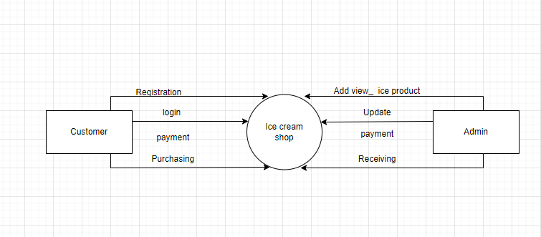

**1st level**

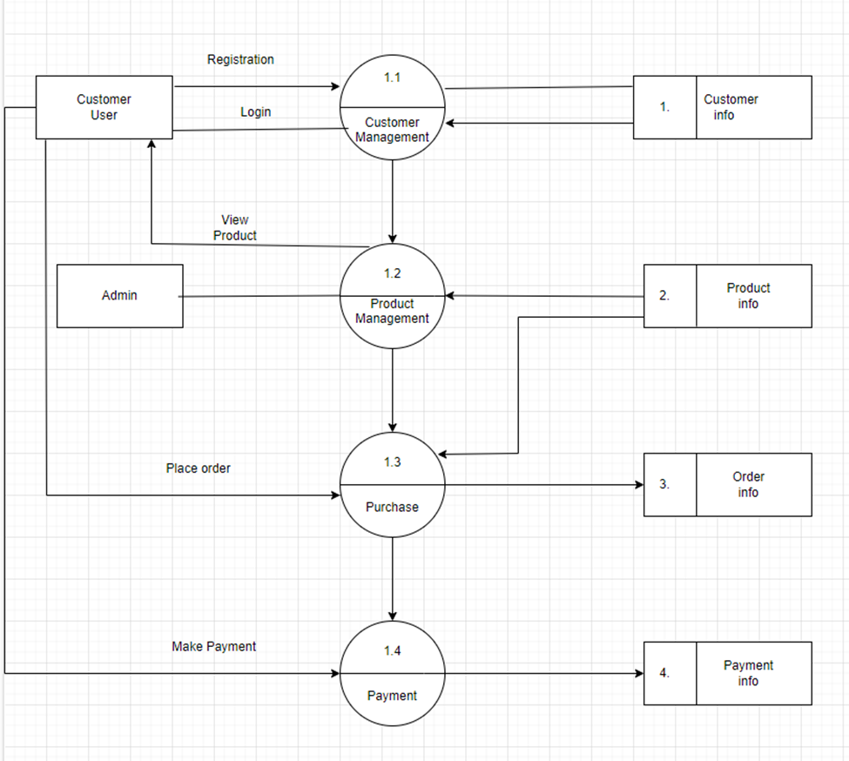

**2nd level**

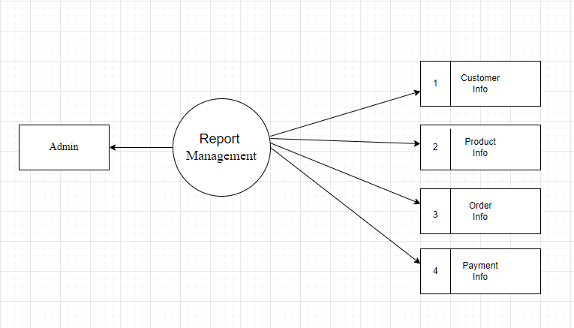

**ERD**

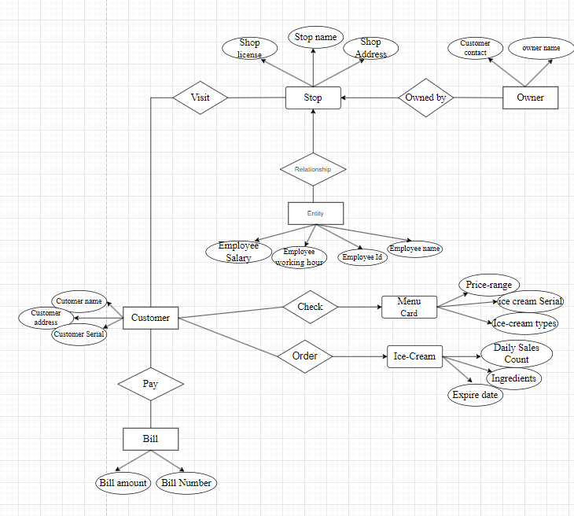

**Activity Diagaram**

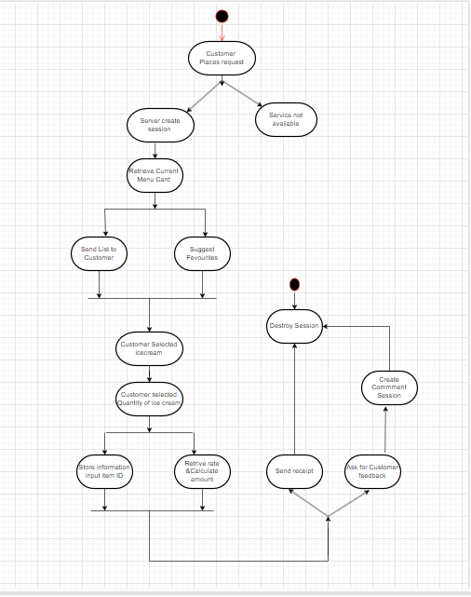

* **Use case Diagram**

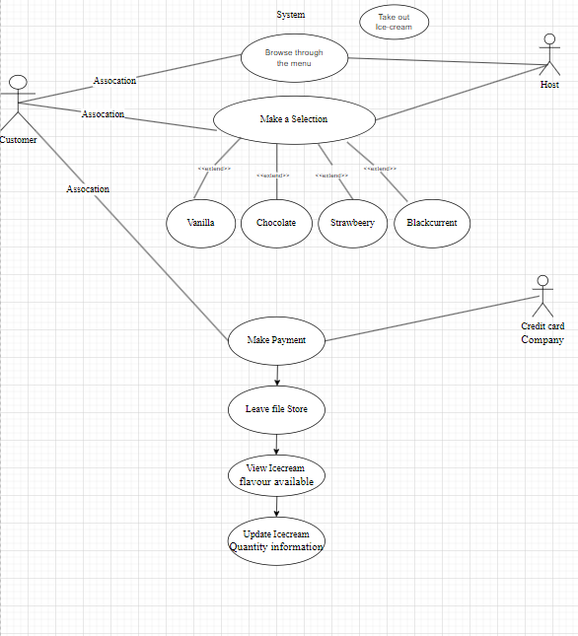

**Sequence Diagram**

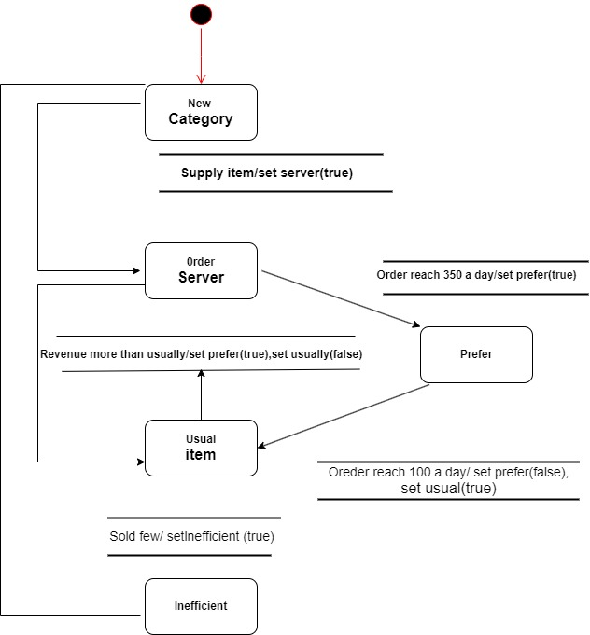

**Component Diagram**

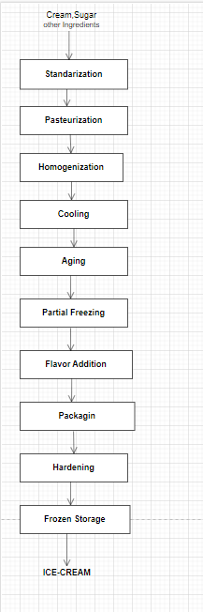

**SYSTEM DESIGN**

**Output-**

**Home page**

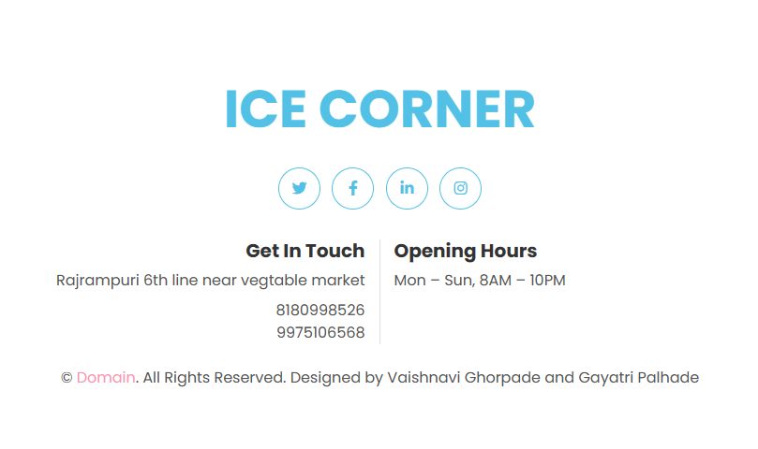

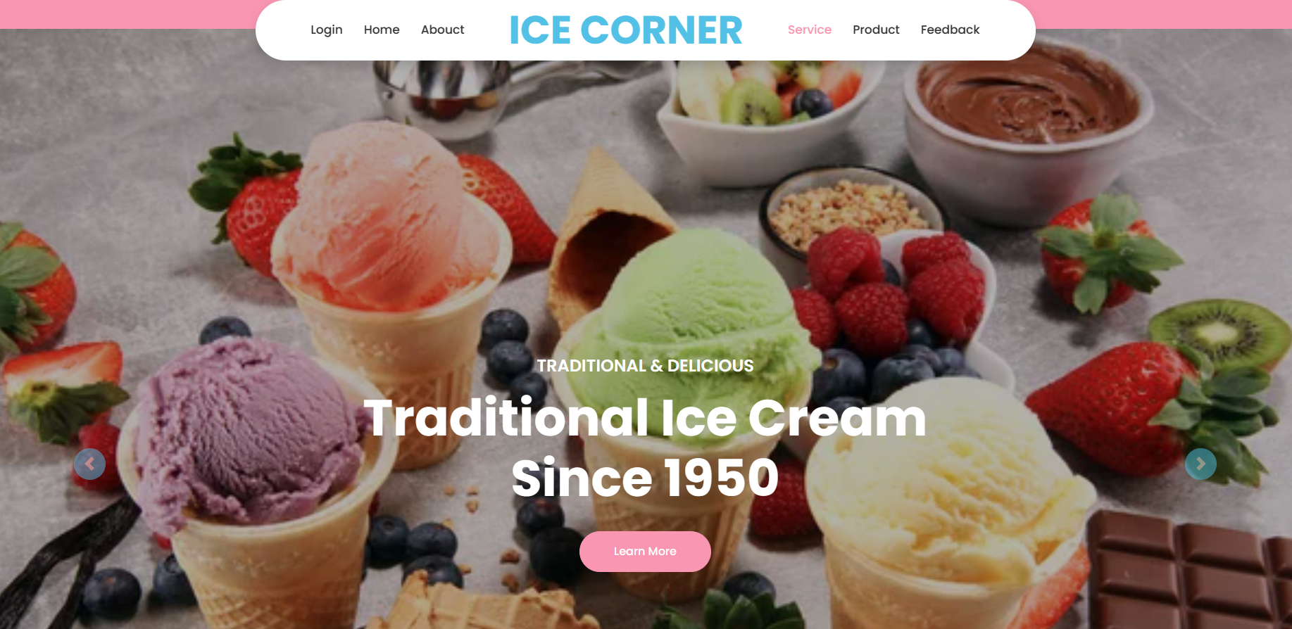

**Service page-**

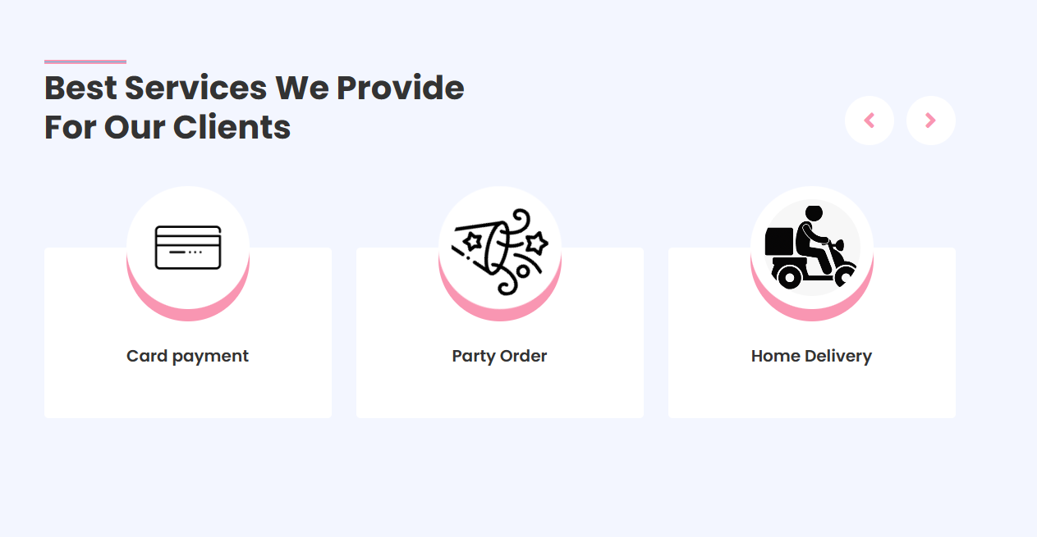

**Products Page-**

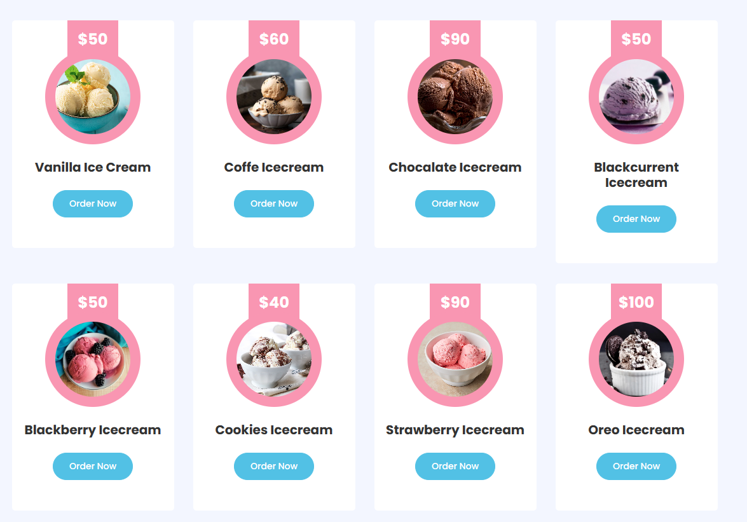

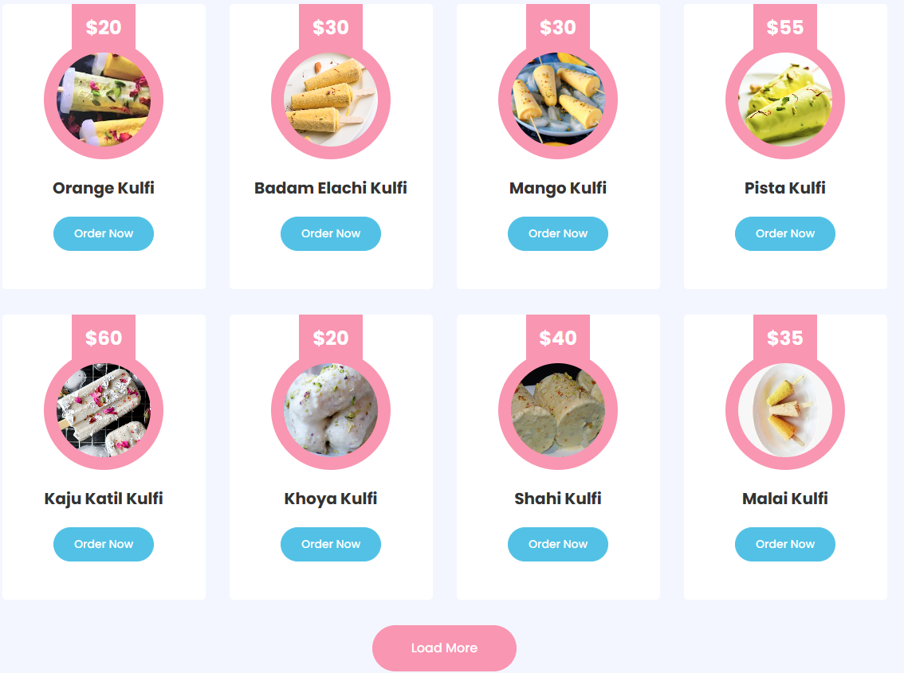

**Order form-**

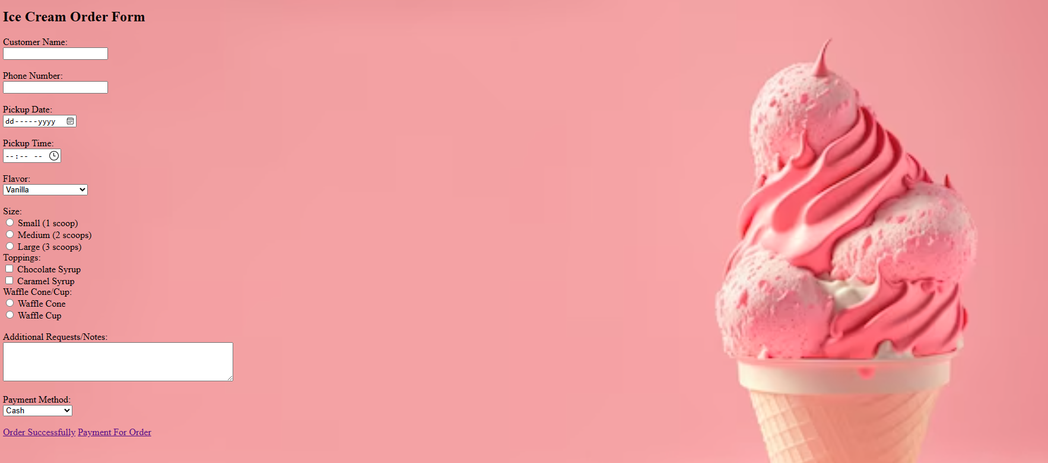

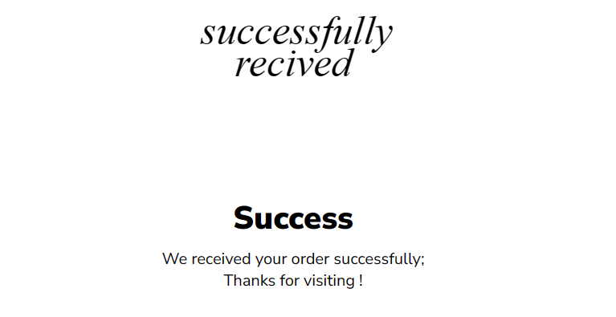

**Payment from-**

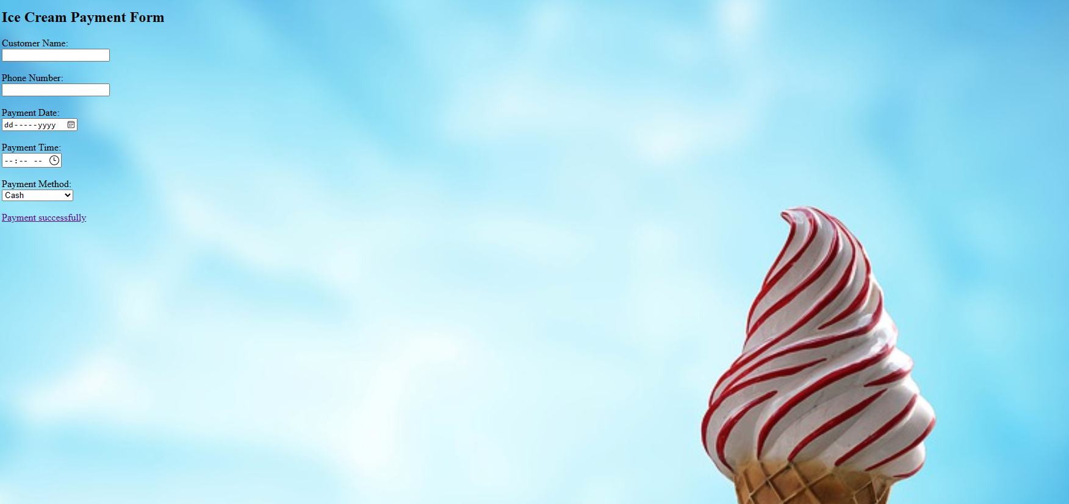

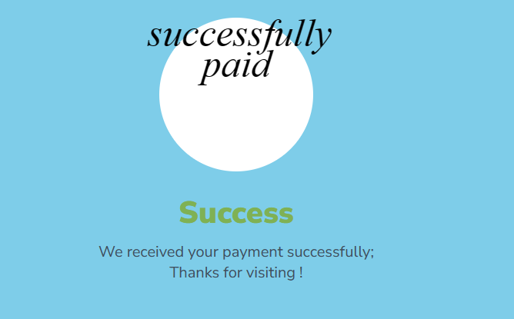

**About us-**

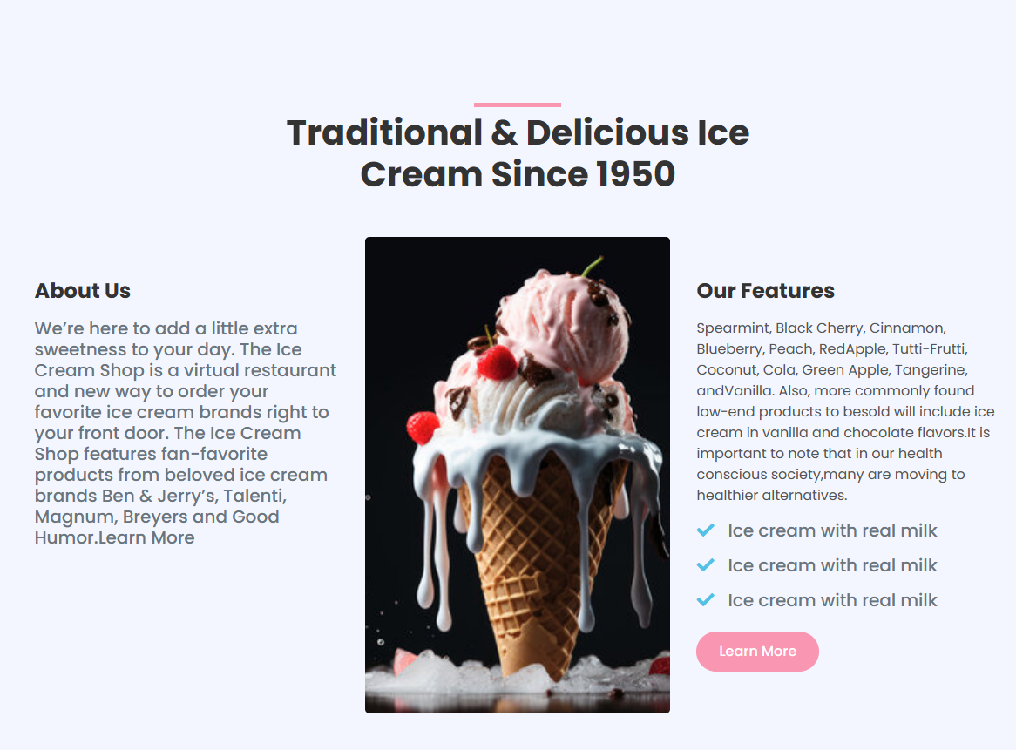

**Chef page-**

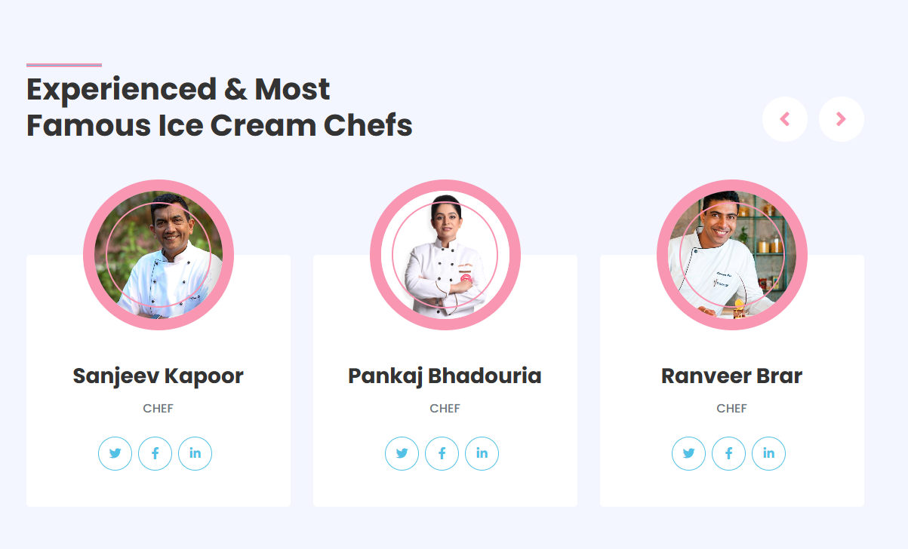

**Review page-**

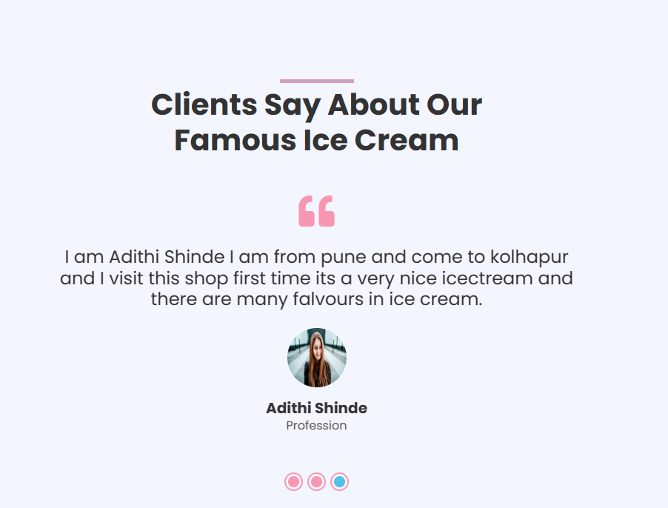

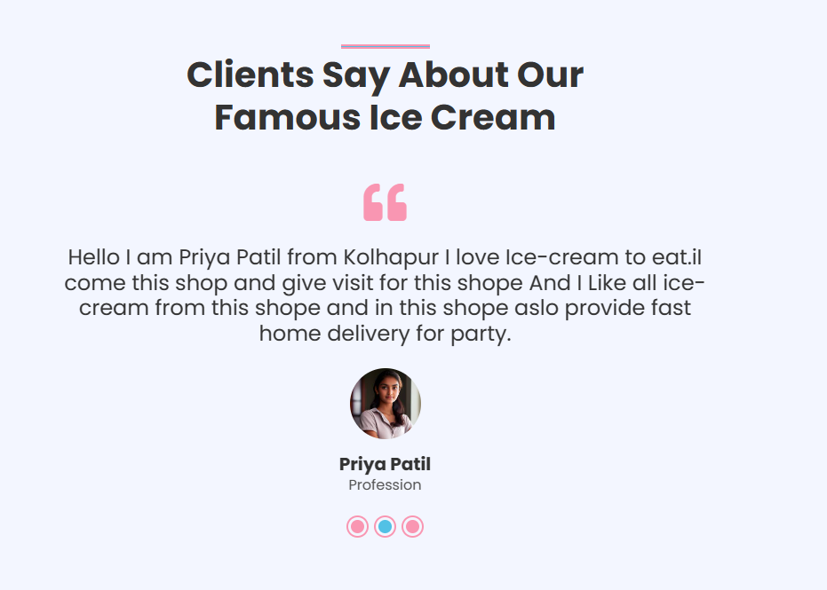

**Feedback from page-**

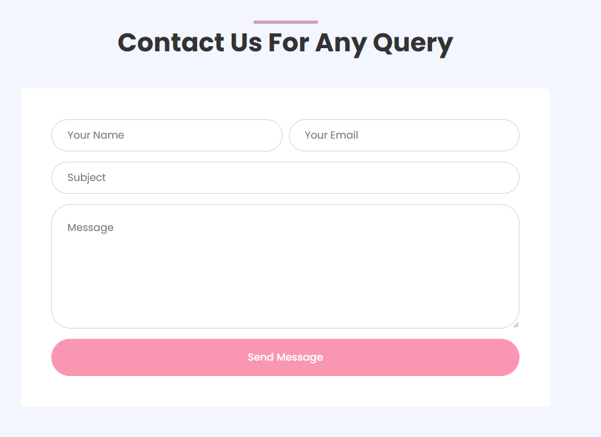

**IMPLEMENTATION**

**Introduction to HTML-**

**HTML** stands for **HyperText Markup Language**. It is the standard markup language used to create web pages. HTML is a combination of Hypertext and Markup language. Hypertext defines the link between web pages. A markup language is used to define the text document within the tag to define the structure of web pages.

This language is used to annotate (make notes for the computer) text so that a machine can understand it and manipulate text accordingly. Most markup languages (e.g. HTML) are human-readable. The language uses tags to define what manipulation has to be done on the text.

HTML was created by Tim Berners-Lee in 1991. The first-ever version of HTML was HTML 1.0, but the first standard version was HTML 2.0, published in 1995. HTML uses predefined tags and elements which tell the browser how to properly display the content. Remember to include closing tags.

**CSS (Cascading Style-sheets)-**

• CSS stands for Cascading Style Sheets. CSS provides visual styling and layout for everything on the web page. It makes each web page look they way that it looks, colour, typography and size. And we can add simply animations and interaction through CSS.

• CSS is among the core language of the open web and is standardlized across Web browsers. Previously, the development of various parts of CSS specification was done synchronously, which allowed the versioning of the latest recommendations. You might have heard about CSS1, CSS2.1, or even CSS3. There will never be a CSS3 or a CSS4; rather, everything is now CSS without a version number.

• CSS has a bit more logic to it. There’s a bit more computer science structure there, which makes it a bit more fragile, and a bit more powerful. It does still have a tremendous amount of resilience. When something goes wrong in CSS, the browser will skip just that section of code and not apply that styling. But it will go on to apply the rest. It might not come out completely correct, the browser will do its best and most of it will work.

**JAVASCRIPT-**

• JavaScript is a programming language that provides the ability to create a more powerful interactivity. The more complex and rich an interface becomes, the more likely that Javascript is used to make that experience seamless for the site’s users. This can be confusing or frustrating for some coders.

• JavaScript, it helps you developing great front-end as well as back-end software using different Javascript based frameworks like jQuery, Node.JS etc. JavaScript is everywhere, it comes installed on every modern web browser and so to learn JavaScript you really do not need any special environment setup. For example Chrome, Mozilla Firefox, Safari and every browser you know as of today, supports JavaScript.

• JavaScript is the most powerful. There are many things that JavaScript can do thar HTML and CSS cannot do. But it’s also the most fragile. If something’s wrong with the code, or the browser is too old to know what that code means, the browser will stop.

The web runs on Mac, Windows, iOS, Android, Linux, other mobile OS’s, Ebook readers, game consoles, televisions, watches. There’s a wide diversity of devices that run HTML, CSS and JavaScript in some form or fashion. That was the entire point of the web, the reason it was invented. To provide a way for pretty remarkable. This is made possible by havin three different kinds of programming languages, each doing part of the job.

**Report**

Report of Sayali Shinde-

|  |
| --- |
| Ice-Cream Shop |

|  |  |
| --- | --- |
| **Customer Name:** | Sayali Mohan Shinde |
| **Product Name:** | Cup icecream balccurrent |
| **Price:** | 50Rs. |
| **Moblie No:** | 3698542789 |
| **Payment Mode:** | Cash |
| **Address:** | Rajrampuri kolhapur |

Report of Shraddha Mate-

|  |
| --- |
| Ice-Cream Shop |

|  |  |
| --- | --- |
| **Customer Name:** | Shraddha Ramkanta mate |
| **Product Name:** | Kaju katil Kulfi |
| **Price:** | 60Rs. |
| **Moblie No:** | 8452996547 |
| **Payment Mode:** | Online |
| **Address:** | Vikram nagar kolhapur |

Report of Snhea Shinde-

|  |
| --- |
| Ice-Cream Shop |

|  |  |
| --- | --- |
| **Customer Name:** | Snhea manoj Shinde |
| **Product Name:** | Oreo icecream , pista kulfi |
| **Price:** | 80,50Rs. |
| **Moblie No:** | 7215569354 |
| **Payment Mode:** | Cash |
| **Address:** | R.K nagar Kolhapur |

**Conclusion and Suggestion**

Based on the results from all the practicals that were carried out we came to a conclusion for each different ice cream

The cheap ice cream contained the highest overall fat content and highest overall air content out of the three ice creams. Due to the high air content it makes the ice cream bad value for money. Furthermore in the melt test it came second which suggests that it contain preservatives rather than natural ingredient which slows down the rate at which the ice creams melts. On one hand the idea of ice cream containing a high amount of air can be seen as bad however from a physical chemistry perspective, ice cream has a colloidal structure. tiny air bubbles and ice crystals are dispersed among liquid water and a network of destabilized fat globules.

The medium ice cream came in the middle in both the fat and air tests. However it was the slowest to melt in the melt test. This could be due to the stabilisers (carrageenan, locust bean gum and gua gum) which holds the fat globules together which slows down the rate of melting. Moreover the choice of stabilisers greatly influences the formation and growth of ice crystals and the rate of the melting. In addition the medium ice cream contains emulsifiers; monoglycerides and diglycerides. These are compounds that are composed of glycerol combined on or two fatty acids. As food additives they interact with other lipids because of their hydrocarbon tail and the remain soluble by virtue of the exposed hydroxyl groups on the glycerol residue

The expensive ice cream had the lowest fat and air content out of all the ice creams. Although the expensive ice cream melted the quickest. This could be because this ice cream had just five ingredients and no preservatives or stabilisers. Therefore the ice cream melts quickly due to lack of preservatives.

Also the lower priced ice creams contain glucose- and fructose syrup and galactose as a substitute for lactose a natural bi-product of milk. One hand this allows people who are lactose intolerant to consume the product but on the the other hand it requires the manufacture to add more additives instead of using natural ingredients.

**ANNEXURE**

|  |
| --- |
| <!DOCTYPE html>  <html lang="en">  <head>  <meta charset="utf-8">  <title>iCREAM - Ice Cream Shop Website Template</title>  <meta content="width=device-width, initial-scale=1.0" name="viewport">    <!------------------------------- Favicon ----------------------->  <link href="img/favicon.ico" rel="icon">  <!-- Google Web Fonts -->  <link rel="preconnect" href="https://fonts.gstatic.com">  <link href="https://fonts.googleapis.com/css2?family=Poppins:wght@400;500;600;700&display=swap" rel="stylesheet">  <!-------------Font Awesome -------------------------->  <link href="https://cdnjs.cloudflare.com/ajax/libs/font-awesome/5.10.0/css/all.min.css" rel="stylesheet">  <!-- Libraries Stylesheet -->  <link href="lib/owlcarousel/assets/owl.carousel.min.css" rel="stylesheet">  <link href="lib/lightbox/css/lightbox.min.css" rel="stylesheet">  <!-- Customized Bootstrap Stylesheet -->  <link href="css/style.css" rel="stylesheet">  </head>  <body>  <!-- Navbar Start -->  <div class="container-fluid position-relative nav-bar p-0">  <div class="container-lg position-relative p-0 px-lg-3" style="z-index: 9;">  <nav class="navbar navbar-expand-lg bg-white navbar-light shadow p-lg-0">  <a href="index.html" class="navbar-brand d-block d-lg-none">  <h1 class="m-0 display-4 text-primary"><span class="text-secondary">ICE CORNER</h1>  </a>  <button type="button" class="navbar-toggler" data-toggle="collapse" data-target="#navbarCollapse">  <span class="navbar-toggler-icon"></span>  </button>  <div class="collapse navbar-collapse justify-content-between" id="navbarCollapse">  <div class="navbar-nav ml-auto py-0">  <a href="login.html" class="nav-item nav-link">Login</a>  <a href="index.html" class="nav-item nav-link">Home</a>  <a href="about.html" class="nav-item nav-link">Abouct</a>  </div>  <a href="index.html" class="navbar-brand mx-5 d-none d-lg-block">  <h1 class="m-0 display-4 text-primary"><span class="text-secondary">ICE CORNER</h1>  </a>  <div class="navbar-nav mr-auto py-0">  <a href="service.html" class="nav-item nav-link active">Service</a>  <a href="product.html" class="nav-item nav-link">Product</a>  <a href="feedback.html" class="nav-item nav-link">Feedback</a>  </div>  </div>  </nav>  </div>  </div>  <!-- ----------------Navbar End -------------------->  <!-- ------------------Carousel Start ------------------>  <div class="container-fluid p-0 mb-5 pb-5">  <div id="header-carousel" class="carousel slide" data-ride="carousel">  <div class="carousel-inner">  <div class="carousel-item active">  <img class="w-100" src="img/img.5.jpg" alt="Image">  <div class="carousel-caption d-flex flex-column align-items-center justify-content-center">  <div class="p-3" style="max-width: 900px;">  <h4 class="text-white text-uppercase mb-md-3">Traditional & Delicious</h4>  <h1 class="display-3 text-white mb-md-4">Traditional Ice Cream Since 1950</h1>  <a href="" class="btn btn-primary py-md-3 px-md-5 mt-2">Learn More</a>  </div>  </div>  </div>  <div class="carousel-item">  <img class="w-100" src="img/img.7.jpg" alt="Image">  <div class="carousel-caption d-flex flex-column align-items-center justify-content-center">  <div class="p-3" style="max-width: 900px;">  <h4 class="text-white text-uppercase mb-md-3">Traditional & Delicious</h4>  <h1 class="display-3 text-white mb-md-4">Made From Our Own Organic Milk</h1>  |<a herf= lass="btn btn-primary py-md-3 px-md-5 mt-2">Learn More</a>  </div>  </div>  <a class="carousel-control-prev" href="#header-carousel" data-slide="prev">  <div class="btn btn-secondary px-0" style="width: 45px; height: 45px;">  <span class="carousel-control-prev-icon mb-n1"></span>  </div>  </a>  <a class="carousel-control-next" href="#header-carousel" data-slide="next">  <div class="btn btn-secondary px-0" style="width: 45px; height: 45px;">  <span class="carousel-control-next-icon mb-n1"></span>  </div>  </a>  </div>  </div>  <!-- ---------------------Carousel End ----------------------->  <!------------------------ About Start ------------------------->  <div class="container-fluid py-5">  <div class="container py-5">  <div class="row justify-content-center">  <div class="col-lg-7">  <h1 class="section-title position-relative text-center mb-5">Traditional & Delicious Ice Cream Since 1950</h1>  </div>  </div>  <div class="row">  <div class="col-lg-4 py-5">  <h4 class="font-weight-bold mb-3">About Us</h4>  <p>Ice cream is a beloved frozen dessert enjoyed by people all over the world. It typically consists of cream, sugar, and flavorings, which are churned and frozen to create a smooth and creamy texture. There are countless variations and flavors of ice cream, ranging from traditional favorites like vanilla, chocolate, and strawberry to more exotic options such as pistachio, mint chocolate chip, and rocky road.  </div>  <div class="col-lg-4" style="min-height: 400px;">  <div class="position-relative h-100 rounded overflow-hidden">  <img class="position-absolute w-100 h-100" src="img/images.9.jpg" style="object-fit: cover;">  </div>  </div>  <div class="col-lg-4 py-5">  <h4 class="font-weight-bold mb-3">Our Features</h4>  <p>Spearmint, Black Cherry, Cinnamon, Blueberry, Peach, RedApple, Tutti-Frutti, Coconut, Cola, Green Apple, Tangerine, andVanilla. Also, more commonly found low-end products to besold will include ice cream in vanilla and chocolate flavors.It is important to note that in our health conscious society,many are moving to healthier alternatives.  Normal soft serve contains 4.5-6.5% fat on average,while Low Fat alternatives contain less than 1% fat. </p>  <h5 class="text-muted mb-3"><i class="fa fa-check text-secondary mr-3"></i>Ice cream with real milk</h5>  <h5 class="text-muted mb-3"><i class="fa fa-check text-secondary mr-3"></i>Ice cream with real milk</h5>  <h5 class="text-muted mb-3"><i class="fa fa-check text-secondary mr-3"></i>Ice cream with real milk</h5>  <a href="" class="btn btn-primary mt-2">Learn More</a>  </div>  </div>  </div>  </div>  <!-------------------About End---------------------------->  <!------------------------ Services Start ------------------------>  <div class="container-fluid py-5">  <div class="container py-5">  <div class="row">  <div class="col-lg-6">  <h1 class="section-title position-relative mb-5">Best Services We Provide For Our Clients</h1>  </div>  <div class="col-lg-6 mb-5 mb-lg-0 pb-5 pb-lg-0"></div>  </div>  <div class="row">  <div class="col-12">  <div class="owl-carousel service-carousel">  <div class="service-item">  <div class="service-img mx-auto">  <img class="rounded-circle w-100 h-100 bg-light p-3" src="img/Home delivery.png" style="object-fit: cover;">  </div>  <div class="position-relative text-center bg-light rounded p-4 pb-5" style="margin-top: -75px;">  <h5 class="font-weight-semi-bold mt-5 mb-3 pt-5">Home Delivery</h5>  </div>  <div class="service-item">  <div class="service-img mx-auto">  <img class="rounded-circle w-100 h-100 bg-light p-3" src="img/take away.png" style="object-fit: cover;">  </div>  <div class="position-relative text-center bg-light rounded p-4 pb-5" style="margin-top: -75px;">  <h5 class="font-weight-semi-bold mt-5 mb-3 pt-5">Take Away</h5>  </div>  <div class="service-item">  <div class="service-img mx-auto">  <img class="rounded-circle w-100 h-100 bg-light p-3" src="img/card payment.png" style="object-fit: cover;">  </div>  <div class="position-relative text-center bg-light rounded p-4 pb-5" style="margin-top: -75px;">  <h5 class="font-weight-semi-bold mt-5 mb-3 pt-5">Card payment</h5>  </div>  </div>  <div class="service-item">  <div class="service-img mx-auto">  <img class="rounded-circle w-100 h-100 bg-light p-3" src="img/party order.png" style="object-fit: cover;">  </div>  <div class="position-relative text-center bg-light rounded p-4 pb-5" style="margin-top: -75px;">  <h5 class="font-weight-semi-bold mt-5 mb-3 pt-5">Party Order</h5>  </div>  </div>  </div>  <!------------------------- Services End ------------------------>  <!------------------------- Gallery Start----------------------->  <div class="container-fluid my-5 py-5 px-0">  <div class="row justify-content-center m-0">  <div class="col-lg-5">  <h1 class="section-title position-relative text-center mb-5">Delicious Ice Cream Made From Our Very Own Organic Milk</h1>  </div>  </div>  <div class="row m-0 portfolio-container">  <div class="col-lg-4 col-md-6 p-0 portfolio-item">  <div class="position-relative overflow-hidden">  <img class="img-fluid w-100" src="img/Gulkand icecream.jpg" alt="">  </div>  </div>  <div class="col-lg-4 col-md-6 p-0 portfolio-item">  <div class="position-relative overflow-hidden">  <img class="img-fluid w-100" src="img/Blackberry IceCream.webp" alt="">  </div>  </div>  <div class="col-lg-4 col-md-6 p-0 portfolio-item">  <div class="position-relative overflow-hidden">  <img class="img-fluid w-100" src="img/Butterscotch icecream.jpg" <div class="col-lg-4 col-md-6 p-0 portfolio-item">  <div class="position-relative overflow-hidden">  <img class="img-fluid w-100" src="img/dry fruits icecream.webp" alt="">  </div>  </div>  <div class="col-lg-4 col-md-6 p-0 portfolio-item">  <div class="position-relative overflow-hidden">  <img class="img-fluid w-100" src="img/butterscotch.3.webp" alt="">  </div>  </div>  <div class="col-lg-4 col-md-6 p-0 portfolio-item">  <div class="position-relative overflow-hidden">  <img class="img-fluid w-100" src="img/Cookies IceCream.jpg" alt="">  </div>  </div>  </div>  </div>  <!------------------------ Gallery End--------------------->  <!-- --------------------------Products Start -------------------->  <div class="container-fluid py-5">  <div class="container py-5">  <div class="row">  <div class="col-lg-6">  <h1 class="section-title position-relative mb-5">Best Prices We Offer For Ice Cream Lovers</h1>  </div>  <div class="col-lg-6 mb-5 mb-lg-0 pb-5 pb-lg-0"></div>  </div>  <div class="row">  <div class="col-12">  <div class="owl-carousel product-carousel">  <div class="product-item d-flex flex-column align-items-center text-center bg-light rounded py-5 px-3">  <div class="bg-primary mt-n5 py-3" style="width: 80px;">  <h4 class="font-weight-bold text-white mb-0">$50</h4>  </div>  <div class="position-relative bg-primary rounded-circle mt-n3 mb-4 p-3" style="width: 150px; height: 150px;">  <img class="rounded-circle w-100 h-100" src="img/Cone icecream.webp" style="object-fit: cover;">  </div>  <h5 class="font-weight-bold mb-4">Cone Icecream</h5>  <a href="order.html" class="btn btn-sm btn-secondary">Order Now</a>  </div>  <div class="product-item d-flex flex-column align-items-center text-center bg-light rounded py-5 px-3">  <div class="bg-primary mt-n5 py-3" style="width: 80px;">  <h4 class="font-weight-bold text-white mb-0">$70</h4>  </div>  <div class="position-relative bg-primary rounded-circle mt-n3 mb-4 p-3" style="width: 150px; height: 150px;">  <img class="rounded-circle w-100 h-100" src="img/cup icecream.webp" style="object-fit: cover;">  </div>  <h5 class="font-weight-bold mb-4">Cup Icecream</h5>  <a href="order.html" class="btn btn-sm btn-secondary">Order Now</a>  </div>  <div class="product-item d-flex flex-column align-items-center text-center bg-light rounded py-5 px-3">  <div class="bg-primary mt-n5 py-3" style="width: 80px;">  <h4 class="font-weight-bold text-white mb-0">$100</h4>  </div>  <div class="position-relative bg-primary rounded-circle mt-n3 mb-4 p-3" style="width: 150px; height: 150px;">  <img class="rounded-circle w-100 h-100" src="img/Stick icecream.jpg" style="object-fit: cover;">  </div>  <h5 class="font-weight-bold mb-4">Stick Icecream</h5>  <a href="order.html" class="btn btn-sm btn-secondary">Order Now</a>  </div>  <div class="product-item d-flex flex-column align-items-center text-center bg-light rounded py-5 px-3">  <div class="bg-primary mt-n5 py-3" style="width: 80px;">  <h4 class="font-weight-bold text-white mb-0">$60</h4>  </div>  <div class="position-relative bg-primary rounded-circle mt-n3 mb-4 p-3" style="width: 150px; height: 150px;">  <img class="rounded-circle w-100 h-100" src="img/mango kulfi.jpg" style="object-fit: cover;">  </div>  <h5 class="font-weight-bold mb-4">Kulfi</h5>  <a href="order.html" class="btn btn-sm btn-secondary">Order Now</a>  </div>  <div class="product-item d-flex flex-column align-items-center text-center bg-light rounded py-5 px-3">  <div class="bg-primary mt-n5 py-3" style="width: 80px;">  <h4 class="font-weight-bold text-white mb-0">$120</h4>  </div>  <div class="position-relative bg-primary rounded-circle mt-n3 mb-4 p-3" style="width: 150px; height: 150px;">  <img class="rounded-circle w-100 h-100" src="img/famliy pack 2.jpg" style="object-fit: cover;">  </div>  <h5 class="font-weight-bold mb-4">Famliy Pack</h5>  <a href="order.html" class="btn btn-sm btn-secondary">Order Now</a>  </div>  </div>  </div>  </div>  </div>  </div>  <!------------------ Products End ---------------------->  <!------------------ Team Start---------------------- -->  <div class="container-fluid py-5">  <div class="container py-5">  <div class="row">  <div class="col-lg-6">  <h1 class="section-title position-relative mb-5">Experienced & Most Famous Ice Cream Chefs</h1>  </div>  <div class="col-lg-6 mb-5 mb-lg-0 pb-5 pb-lg-0"></div>  </div>  <div class="row">  <div class="col-12">  <div class="owl-carousel team-carousel">  <div class="team-item">  <div class="team-img mx-auto">  <img class="rounded-circle w-100 h-100" src="img/Chef Sanjeev Kapoor.jpg" style="object-fit: cover;">  </div>  <div class="position-relative text-center bg-light rounded px-4 py-5" style="margin-top: -100px;">  <h3 class="font-weight-bold mt-5 mb-3 pt-5">Sanjeev Kapoor</h3>  <h6 class="text-uppercase text-muted mb-4">Chef</h6>  <div class="d-flex justify-content-center pt-1">  <a class="btn btn-outline-secondary btn-social mr-2"><i class="fab fa-twitter"></i></a>  <a class="btn btn-outline-secondary btn-social mr-2" href=""><i class="fab fa-facebook-f"></i></a>  <a class="btn btn-outline-secondary btn-social mr-2" href=""><i class="fab fa-linkedin-in"></i></a>  </div>  </div>  </div>  <div class="team-item">  <div class="team-img mx-auto">  <img class="rounded-circle w-100 h-100" src="img/chef pankaj bhadouria.png" style="object-fit: cover;">  </div>  <div class="position-relative text-center bg-light rounded px-4 py-5" style="margin-top: -100px;">  <h3 class="font-weight-bold mt-5 mb-3 pt-5">Pankaj Bhadouria</h3>  <h6 class="text-uppercase text-muted mb-4">Chef</h6>  <div class="d-flex justify-content-center pt-1">  <a class="btn btn-outline-secondary btn-social mr-2" href="#"><i class="fab fa-twitter"></i></a>  <a class="btn btn-outline-secondary btn-social mr-2" href="#"><i class="fab fa-facebook-f"></i></a>  <a class="btn btn-outline-secondary btn-social mr-2" href="#"><i class="fab fa-linkedin-in"></i></a>  </div>  </div>  </div>  <div class="team-item">  <div class="team-img mx-auto">  <img class="rounded-circle w-100 h-100" src="img/chef ranveer brar.jpg" style="object-fit: cover;">  </div>  <div class="position-relative text-center bg-light rounded px-4 py-5" style="margin-top: -100px;">  <h3 class="font-weight-bold mt-5 mb-3 pt-5">Ranveer Brar</h3>  <h6 class="text-uppercase text-muted mb-4">Chef</h6>  <div class="d-flex justify-content-center pt-1">  <a class="btn btn-outline-secondary btn-social mr-2" href="#"><i class="fab fa-twitter"></i></a>  <a class="btn btn-outline-secondary btn-social mr-2" href="#"><i class="fab fa-facebook-f"></i></a>  <a class="btn btn-outline-secondary btn-social mr-2" href="#"><i class="fab fa-linkedin-in"></i></a>  </div>  </div>  </div>  <div class="team-item">  <div class="team-img mx-auto">  <img class="rounded-circle w-100 h-100" src="img/vikas khanna chef.jpg" style="object-fit: cover;">  </div>  <div class="position-relative text-center bg-light rounded px-4 py-5" style="margin-top: -100px;">  <h3 class="font-weight-bold mt-5 mb-3 pt-5">Vikas Khan</h3>  <h6 class="text-uppercase text-muted mb-4">Chef</h6>  <div class="d-flex justify-content-center pt-1">  <a class="btn btn-outline-secondary btn-social mr-2" href="#"><i class="fab fa-twitter"></i></a>  <a class="btn btn-outline-secondary btn-social mr-2" href="#"><i class="fab fa-facebook-f"></i></a>  <a class="btn btn-outline-secondary btn-social mr-2" href="#"><i class="fab fa-linkedin-in"></i></a>  </div>  </div>  </div>  </div>  <!-- ---------------------------Team End------------------>  <!-- -----------------------Testimonial Start -------------->  <div class="container-fluid py-5">  <div class="container py-5">  <div class="row justify-content-center">  <div class="col-lg-6">  <h1 class="section-title position-relative text-center mb-5">Clients Say About Our Famous Ice Cream</h1>  </div>  </div>  <div class="row justify-content-center">  <div class="col-lg-8">  <div class="owl-carousel testimonial-carousel">  <div class="text-center">  <i class="fa fa-3x fa-quote-left text-primary mb-4"></i>  <h4 class="font-weight-light mb-4">Hello I am Radika i always visit to Ice-Cream Conrner I love all icecream from this shop and the staff of this shop is very active and provide all facility .</h4>  <img class="img-fluid mx-auto mb-3" src="img/Radika img.jpg" alt="">  <h5 class="font-weight-bold m-0">Radika Chavan</h5>  <span>Profession</span>  </div>  <div class="text-center">  <i class="fa fa-3x fa-quote-left text-primary mb-4"></i>  <h4 class="font-weight-light mb-4">Hello I am Priya Patil from Kolhapur I love Ice-cream to eat.iI come this shop and give visit for this shope And I Like all ice-cream from this shope and in this shope aslo provide fast home delivery for party.</h4>  <img class="img-fluid mx-auto mb-3" src="img/priya img.jpg" alt="">  <h5 class="font-weight-bold m-0">Priya Patil</h5>  <span>Profession</span>  </div>  <div class="text-center">  <i class="fa fa-3x fa-quote-left text-primary mb-4"></i>  <h4 class="font-weight-light mb-4">I am Adithi Shinde I am from pune and come to kolhapur and I visit this shop first time its a very nice icectream and there are many falvours in ice cream.</h4>  <img class="img-fluid mx-auto mb-3" src="img/aditi img.jpg" alt="">  <h5 class="font-weight-bold m-0">Adithi Shinde</h5>  <span>Profession</span>  </div>  </div>  </div>  <!----------- Testimonial End --------------->  <!------------- Footer Start ----------------->  <div class="container-fluid footer bg-light py-5" style="margin-top: 90px;">  <div class="container text-center py-5">  <div class="row">  <div class="col-12 mb-4">  <a href="index.html" class="navbar-brand m-0">  <h1 class="m-0 mt-n2 display-4 text-primary"><span class="text-secondary">ICE CORNER</h1>  </a>  </div>  <div class="col-12 mb-4">  <a class="btn btn-outline-secondary btn-social mr-2" href="https://twitter.com/i/flow/login"><i class="fab fa-twitter"></i></a>  <a class="btn btn-outline-secondary btn-social mr-2" href="https://www.facebook.com/"><i class="fab fa-facebook-f"></i></a>  <a class="btn btn-outline-secondary btn-social mr-2" href="https://www.linkedin.com/login"><i class="fab fa-linkedin-in"></i></a>  <a class="btn btn-outline-secondary btn-social" href="https://www.instagram.com/?hl=en"><i class="fab fa-instagram"></i></a>  </div>  <div class="col-12 mt-2 mb-4">  <div class="row">  <div class="col-sm-6 text-center text-sm-right border-right mb-3 mb-sm-0">  <h5 class="font-weight-bold mb-2">Get In Touch</h5>  <p class="mb-2">Rajrampuri 6th line near vegtable market</p>  <p class="mb-0">8180998526</p>  <p class="mb-0">9975106568</p>  </div>  <div class="col-sm-6 text-center text-sm-left">  <h5 class="font-weight-bold mb-2">Opening Hours</h5>  <p class="mb-2">Mon – Sun, 8AM – 10PM</p>  </div>  </div>  </div>  <div class="col-12">  <p class="m-0">&copy; <a href="#">Domain</a>. All Rights Reserved. Designed by Vaishnavi Ghorpade and Gayatri Palhade</p>  <!-------------- Footer End ---------------------->  <!-- ---------------Back to Top ------------------>  <a href="#" class="btn btn-secondary px-2 back-to-top"><i class="fa fa- angle-double-up"></i></a>  <!-- JavaScript Libraries -->  <script src="https://code.jquery.com/jquery-3.4.1.min.js"></script>  <script src="https://stackpath.bootstrapcdn.com/bootstrap/4.4.1/js/bootstrap.bundle.min.js"></script>  <script src="lib/easing/easing.min.js"></script>  <script src="lib/waypoints/waypoints.min.js"></script>  <script src="lib/owlcarousel/owl.carousel.min.js"></script>  <script src="lib/isotope/isotope.pkgd.min.js"></script>  <script src="lib/lightbox/js/lightbox.min.js"></script>  </body>  </html> |

Kamala College, Kolhapur

**Student Guide Meet Record**

2023-2024

|  |  |  |
| --- | --- | --- |
| **Title of Project** | **Ice-Cream Shop** | **Class:**BCA-II(Sem-IV) |
| **Student Name** | Vaishnavi Anandrao Ghorpade  Gayatri Dashrath Palhade | **Guide Name:**  Smt. Rhoni Lokare |

|  |  |  |  |  |  |
| --- | --- | --- | --- | --- | --- |
| **Sr.** | **Date** | **Description** | **Signature of Guide** | **Signature of Student** | **Guide Remark** |
| 1 |  | Problem Identification and Topic and Title finalization  (1st week of semester) |  |  |  |
| 2 |  | SRS submission and approval (6th week of semester) |  |  |  |
| 3 |  | Logical Design of system (DFD, System flowchart, ERD, UML diagram, Decision tables, Decision trees, site map which is applicable)  (7th week of semester) |  |  |  |
| 4 |  | Database Design (8th week of semester) |  |  |  |
| 5 |  | I/O Design (with reports) (10th week of semester) |  |  |  |
| 6 |  | Submission of Draft Project Report (11th week of semester) |  |  |  |
| 7 |  | Submission of Final Project Report (12th week of semester) |  |  |  |

**REFERENCES**

[1] JavaScript Enlightenment, Cody Lindley-First Edition, based on JavaScript 1.5, ECMA-262, Edition

[2] Mc GrawHill’s , Java : The complete reference 7th Edition, Herbert Schildit

[3] Complete CSS Guide, Maxine Sherrin and John Allsopp-O’ReillyMedia; September 2012

[4] <http://www.w3schools.com/htm;/defualt.asp,http://www.w3schools.com/css/default.asp,http://>

www.w3schools.com/js/default.as